**S. AJITH KUMAR**

**192011004**

**3.Railway Reservation System**

**1.Class Diagram**

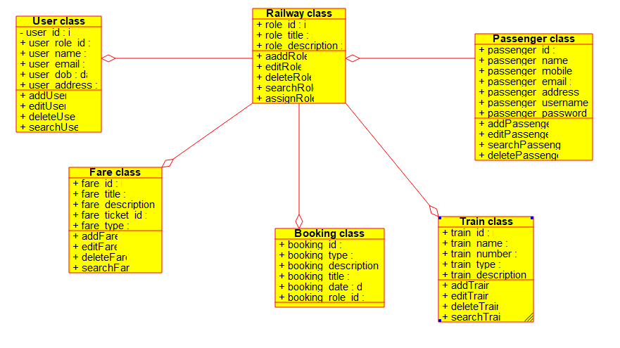

**2.Usecase Diagram**

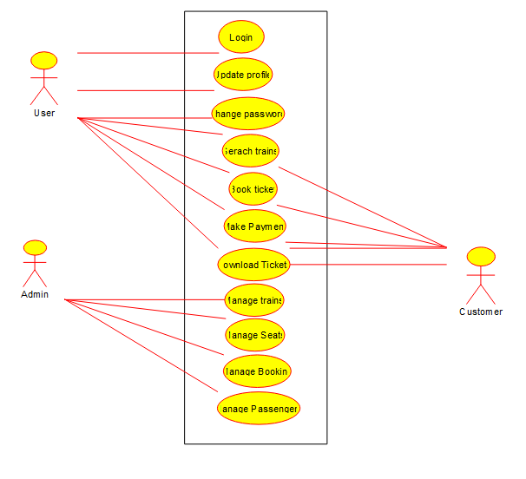

**3.Sequence Diagram**

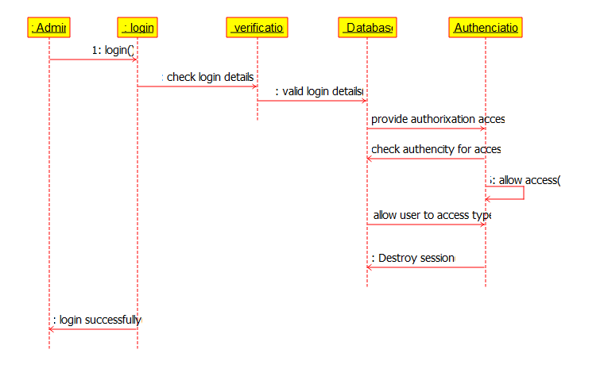

**4.State Diagram**

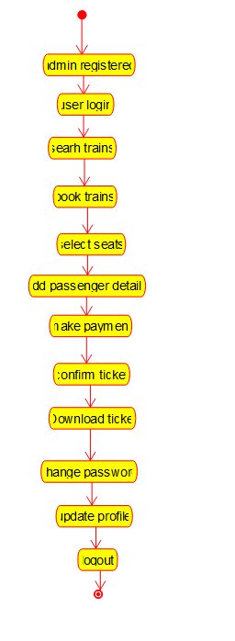

**5.Activity Diagram**

